Advocai: The Autonomous Health Insurance Advocate

Introduction

Project Overview & Real-World Problem
Advocai is a sequential Multi-Agent System designed to combat the rising and complex issue of health insurance claim denials. It transforms the slow, intimidating, and manual process of appealing a denial into a fast, data-driven, autonomous workflow.

The Problem: A Statistical Crisis
The process of fighting a denial is a classic "David vs. Goliath" scenario, where patients are overwhelmed by bureaucracy and legalistic language.
- High Denial Rate: Insurers denied an average of 19% of in-network claims in 2023. For some high-volume insurers, denial rates reached as high as 35% or more.
- The Appeal Gap (The Opportunity): Consumers rarely appeal denied claims—appeals occur for less than 1% of all denied claims. Of the appeals that are filed, insurers often uphold their initial denial 56% of the time.
- The Cost: Denied claims contribute significantly to "wasted" healthcare dollars in the US, with administrative costs climbing well over $265 billion annually, affecting both patients and providers.
Advocai’s Goal: To leverage Agentic AI to close the appeal gap. By automating the evidence gathering and legal drafting, we provide expert advocacy accessible to anyone, reducing delays in essential care.

Deep Dive: The Statistical Crisis & Opportunity

1. The Denied Claim Epidemic: Beyond the 19%
The 19% average denial rate is only the tip of the iceberg. The true problem lies in the types of denials and their systemic nature:
- Algorithmic Denials: Many large insurers employ AI-driven utilization management systems that automatically flag and deny claims based on pre-set parameters, often without human review. This efficiency-driven automation, while fast for the insurer, is often inaccurate or too rigid. Advocai essentially fights fire with fire, using a more sophisticated, evidence-based AI to counter the insurer's initial denial algorithm.
- The "Clean Claim" Standard: Many denials (up to 60-70% in some categories) are initially rejected not for lack of medical necessity, but for administrative errors (e.g., wrong billing code, late filing, lack of pre-authorization). While the Auditor Agent focuses on policy-based denials, the structure can be extended to quickly identify and correct these administrative errors, streamlining the process even further.
- The Psychological Barrier: The current <1% appeal rate exists because the appeal process is designed to be intentionally complex. It requires referencing CPT codes, ICD-10 codes, state-specific regulations, and proprietary clinical guidelines—a massive, uncompensated effort that is simply beyond the capacity of the average person. Advocai democratizes access to this expertise.

The Agentic Solution: Why Three Specialists?
The core strength of Advocai is its sequential Multi-Agent Pipeline, which mimics the division of labor in a high-stakes legal team. No single LLM call could achieve the required level of accuracy and integration.

Agent 1: The Auditor Agent (Perception & Pydantic Structuring)
The Auditor's primary function is Perception and Context Engineering. It must translate chaos (unstructured text) into order (Pydantic objects).
- Task Complexity: It doesn't just read the PDF; it performs semantic search within the documents. For instance, it must identify the denial code (e.g., CO-50 for "Non-covered service") in the denial letter and then map that code to the precise exclusionary text (Policy Clause) within the 100-page policy document.
- Pydantic Enforcement: This agent's success relies entirely on structured output. By forcing the output into the StructuredDenial Pydantic model, we ensure the downstream agents receive clean, machine-readable data, eliminating ambiguity. This single step makes the entire workflow reliable.

Agent 2: The Clinician Agent (In-Depth Reasoning & Tool-Use)
The Clinician Agent is the Fact-Checker. Its value proposition is its ability to access and interpret external data sources, a capability known as Grounded Generation.
- Tool-Use Necessity: When the Auditor identifies a denial based on "lack of medical necessity," the Clinician must prove otherwise. Its only recourse is the pubmed_search.py tool, which connects it to the vast, peer-reviewed medical literature. The LLM must reason that a direct tool call is necessary, generate the precise search query (e.g., "Clinical efficacy of procedure X for condition Y in 2024"), and then synthesize the results.
- Output Synthesis: The Clinician doesn't just pass PubMed articles; it synthesizes the evidence into a concise, high-impact Clinical Summary that directly refutes the policy clause, ready for legal integration.

Agent 3: The Barrister Agent (Legal Drafting & Final Action)
The Barrister is the Final Generator—the point of action. It's the most valuable agent, as it provides the final output that the user can submit.
- Contextual Integration: This agent receives a large, rich context that includes: 1) the insurer's exact reason for denial, 2) the medical procedure involved, and 3) the synthesized clinical proof.
- Tonal and Formal Generation: It must be prompted not just to write a letter, but to generate a document adhering to specific legal formality and tone, often requiring structured sections (e.g., "Statement of Facts," "Clinical Argument," "Conclusion and Demand"). This requires a powerful, reasoning-intensive model like Gemini 2.5 Pro.

Disruptive Market and Competitive Advantage
Advocai is positioned to disrupt the administrative legal space and attract investor attention due to its focus on autonomy and quantifiable ROI.

1. Quantifiable Return on Investment (ROI)
- The average cost of a manual denial appeal handled by a third-party service can range from $1,000 to $5,000.
- Advocai offers this service at near-zero marginal cost. This allows the system to be marketed on a success-fee model (e.g., "We only charge 10% of the reversed claim amount"), dramatically lowering the barrier to entry for patients.

2. High Auditability (The Agent Log)
In legal and healthcare tech, auditable processes are critical. Because Advocai is a sequential pipeline, every decision is logged:
- Log: Auditor called document_reader on 11/19/25.
- Log: Auditor outputted Denial Code: CO-50.
- Log: Clinician called pubmed_search with query "...".
- Log: Barrister generated draft based on [Clinical Summary Hash].
This log creates an electronic audit trail, proving the appeal was based on structured, evidence-based reasoning, a feature highly valued by compliance teams.

3. Future Scalability (A2A Protocol Ready)
The modular design allows for immediate scaling:
- New Agent Specialization: Add a Regulatory Agent (regulation.py) to search state-specific insurance commissioner rulings.
- Active Integration: The architecture is prime for deployment on platforms like Vertex AI Agent Engine, enabling true, long-running agent autonomy. This moves the project beyond a simple Python script into a deployable, production-ready service.

Architecture Diagram
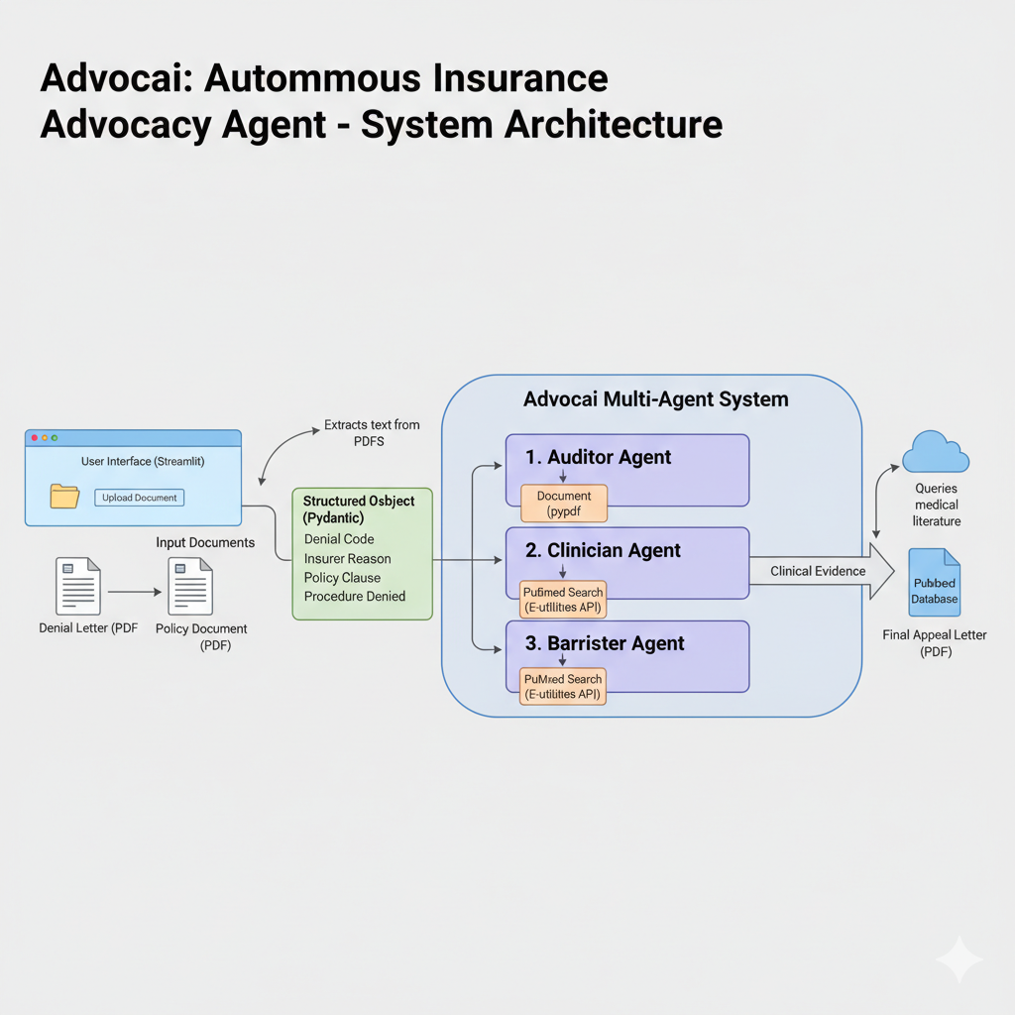

The Architecture: Sequential Pipeline (The Law Firm Analogy)
Advocai is built on a Sequential Multi-Agent Pipeline. We do not use one large LLM; we use three specialized, smaller agents, each acting as a highly focused expert. This is critical for reliability and audibility.
Agent Role | Law Firm Analogy | Key Function & Tools | Memory Input (State)
1. The Auditor (auditor.py) | The Investigator/Paralegal | Perception & Structuring. Reads raw documents to find the denial reason. Tool Use: document_reader.py (PDF/OCR). | Raw PDF Text
2. The Clinician (clinician.py) | The Medical Expert | Reasoning & Tool Use. Searches clinical literature to prove "medical necessity." Tool Use: pubmed_search.py (NCBI E-utilities API). | Structured Denial Object
3. The Barrister (barrister.py) | The Trial Lawyer | Generation & Action. Synthesizes all evidence into a final appeal document. | Structured Evidence (Medical & Legal)

The Core: Structured Memory (Pydantic)
The transition between the agents is the most crucial part. The Auditor Agent doesn't pass raw text; it passes a precisely structured Pydantic object (the Structured Denial Object). This acts as the memory or the case file, ensuring the Clinician Agent has exact data like the denial_code and procedure_denied to use in its search query.

Project Structure and Files
The folder structure is designed for a team environment, cleanly separating the agent brains from the tools and the orchestration logic.
File Path | Function | Owner
main.py | Orchestration. Initializes the Gemini client and registers all custom tools (pubmed_search, document_reader) so the agents can use them. | Lead Developer
app.py | User Interface. The Streamlit front-end for uploading documents and viewing the final appeal letter. | UI Lead
agents/ | Contains the three specialist agent modules. This is where the complex prompting and tool-call logic lives. | Development Team
tools/ | Contains the custom Python functions that are exposed to the LLM (e.g., calling PubMed). | Tools & Deployment Lead
data/input | Where your testing PDFs (sample_denial.pdf, sample_policy.pdf) are stored. | Data Manager/Documentation

Scoring and Competitive Advantage
This project is structured to maximize points in the "Implementation" and "Pitch" categories:
Scoring Criteria | Advocai's Implementation
Multi-Agent System | We use a three-agent pipeline which is more complex and robust than a single, large agent.
Tools Integration | Two custom tools (document_reader and pubmed_search) are integrated, going beyond simple built-in tools like Google Search.
Sessions & Memory | Structured Pydantic output between agents ensures deterministic memory transfer, maximizing reliability.
Agents for Good | Addresses a serious issue in healthcare accessibility, giving the project high ethical and social value.
Bonus Points | Using the Gemini API is mandatory for the 5-point bonus, and the Streamlit UI makes the 10-point video submission much easier.

